Jeff Sherard
CSC160C11
6/22/2013

Documentation for Ch04_Ex14 Program

Problem Analysis

Figure out the number of lines that can be printed on a piece of paper

Depends on:
- paperHeight
- paperWidth
- pointSize
- lineSpacing
- topMargin
- bottomMargin
- leftMargin
- rightMargin

Constant:
1 inch = 72 points

Assume:
All characters are the same point size
All lines are either single-space or double-space
All lines are printed along the width of the paper (ie 8.5” x 11” piece of paper maximum wideth = 8.5”)

Write a program that calculates the number of lines that can be printed on a paper based on the following input from the user:
- The length and width, in inches, of the paper
- The top, bottom, left and right margins
- The point size of a line
- If the lines are double spaced, then double the point size of each character

Algorithm

- Define variables:
  - paperHeight
  - paperWidth
  - leftMargin
  - rightMargin
  - topMargin
  - bottomMargin
  - pointSize
  - printHeight
  - printWidth
  - linePage
  - charLine
  - lineSpacing

- Get input:
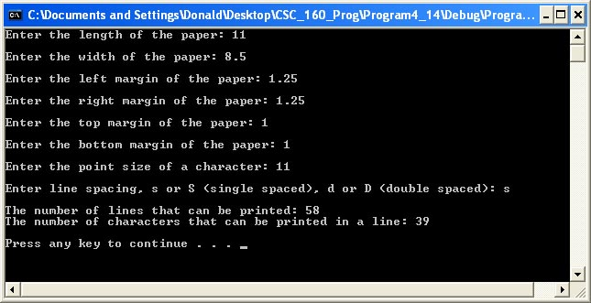

- Calculate:

Constant: 1” = 72 pts
printWidth = paperWidth – leftMargin – rightMargin
printHeight = paperLength – topMargin – bottomMargin
charactersLine = (printWidth * constant) / font
linesPageSingle = (printHeight * constant) / (pointSize)
linesPageDouble = (printHeight * constant) / (pointSize * 2)

- Output:
  - The number of lines that can be printed: 58
  - The number of characters that can be printed in a line: 39

User Documentation

To run the program the user will double click Ch4_Ex14.exe located on the C drive. After the program has loaded and the design is displayed, the user will be prompted to, “Press any key to continue…” which will terminate the program. Output will be displayed on the screen.

